It is also for specific use-cases
Proxy Design Pattern
Suppose we have user and resource. User send some request and resource reply it
request
Resource
User

Now we introduce a proxy in between. Proxy will take request from user validate it and send to resource, resource will send reply to proxy and then from proxy it will again go to user

proxy
Resource
User

Why proxy:-
- We don’t want user to directly talk with resource as resource can be critical data so validate first and then proceed. – for authentication
- To validate data coming from user and then send request to resource
- Suppose resource is somewhere external like internet and user and proxy are local object. Proxy go over the internet and call resource and send back to user. User thinks it’s only talking the local object proxy but don’t know how proxy doing it at the backend
So proxy behaves like a resource and user don’t able to differentiate whether it is talking to proxy or resource. User don’t need to know whether it is talking to proxy or resource.
Proxy act as a representative of resource.
Types of proxy
- Virtual
- Protection
- Remote
Virtual proxy
Example - Suppose we have a method display() which takes path of image and displays it
Suppose before displaying it do certain things like load from disc, compress the image, filter the image. So you can do this constructor as well:-
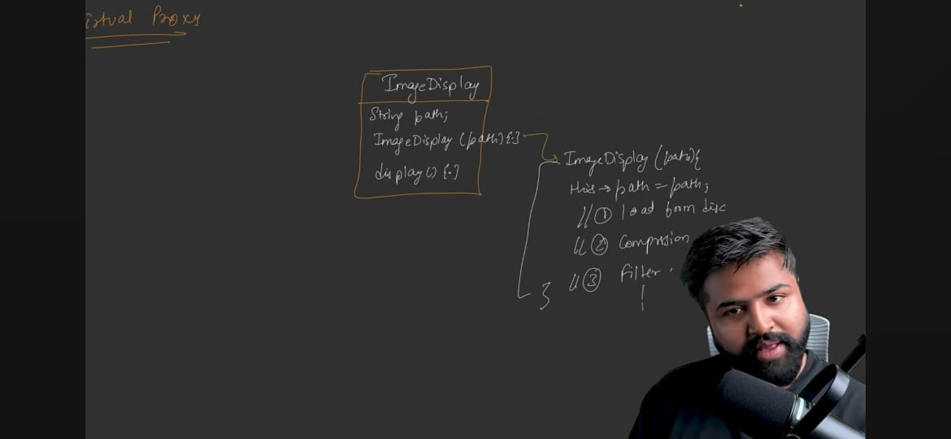
Now our client code:-
ImageDisplay img = new ImageDisplay(p); //Expensive operation as it is doing things in constructor
Img.display() //displays the image
Now suppose that client never call Img.display() then our lot of time/memory got wasted in creating the object
Because client never called display()
So to rectify it we use proxy
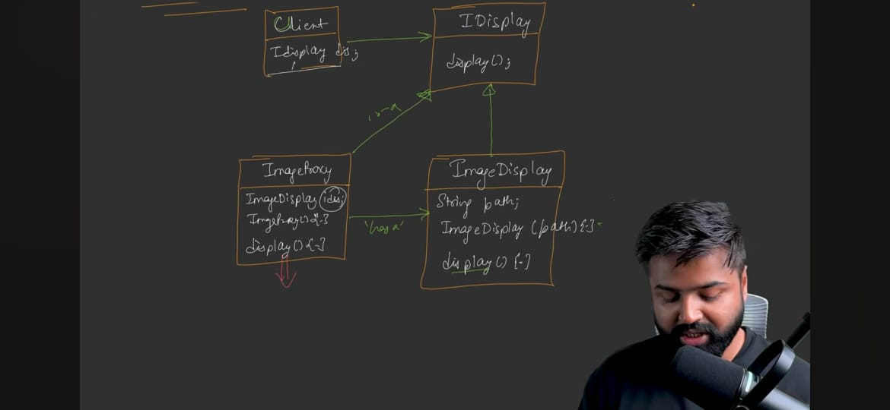
In IDisplay of Client we will pass the object proxy not actual one. Constructor of ImageProxy just assign idis with null
Display method of ImageProxy:-
display(){
If(idis == null){
Idis = new ImageDisplay();
Idis->display();
}
}
So to protect any expensive resource we use Virtual proxy.
But here our display method will become slow but object creation becomes fast. So there is a trade-off
Protection Proxy
Example – suppose we have a Document reader which has method unlockPDF which unlock the pdf file provided
Now, we don’t want everyone to unlock tis pdf there must be some restriction for certain user
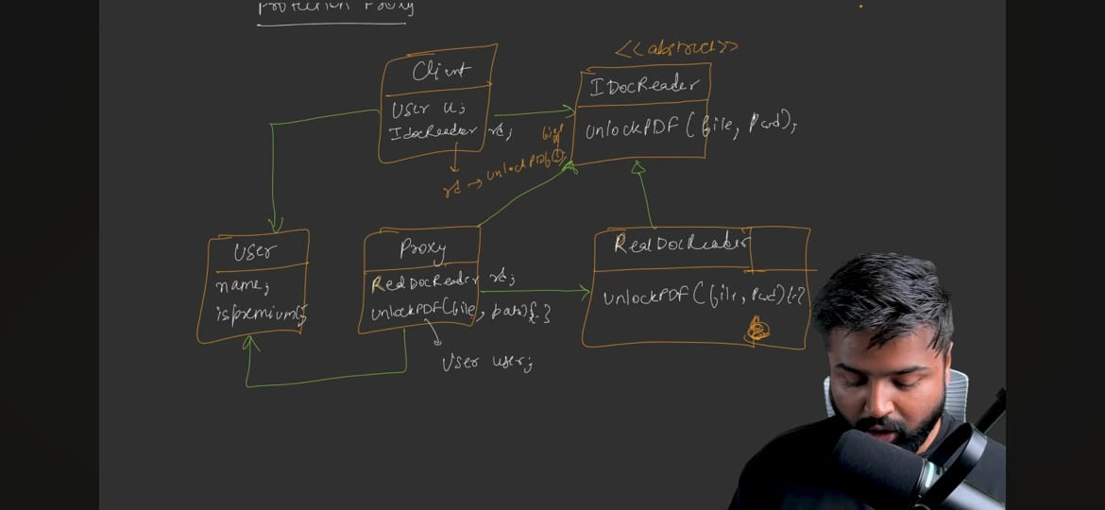
here also client will have the proxy object in IdocReader rd
So when client call rd.unlockPDF() then it first check whether the user is right person or not and then it calls the actual unlockPDF() by using the object of RealDocReader
Code of unlockPDF() of proxy :-
unlockPDF(){
if(user.isPremium()){
rd.unlockPDF();
}
Else{ throws exception}
}
So to protect any resource from un-authorize access we use Protection proxy
Remote Proxy
Example – suppose we have DataService class which takes out the data from some DB
Now if client directly want to fetchData() then it has to first establish connection with remote service and then call fetchData()
But we don’t want client to know that it is on which server, to which remote server it has to establish connection and so on. Client just have to call fetchData() that’s it.
So we introduce proxy here

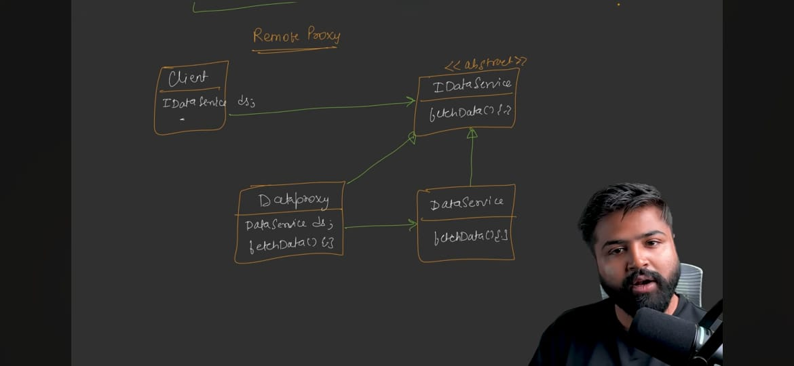
Now client will have object of DataProxy in ds reference not actual DataService.
So when you create :-
IDataService ds = new DataProxy()
then it will establish connection in constructor of DataProxy or in fetchData() method of DataProxy() and then call fetchData() of actual DataService. It depends on you where you want to establish connection
- In Constructor – Eager loading
- In fetchData() – lazy loading
Code of fetchData() in Proxy:- for lazy loading
fetchData(){
if(dis == null){
//connection establish
Ds.fetchdata();
}
}
So remote proxy becomes the proxy of those which exist somewhere else over the internet
Note – UML Diagram of all types of proxy is exactly same, just there intent is different
Code – see notes…..
Standard UML Diagram:-
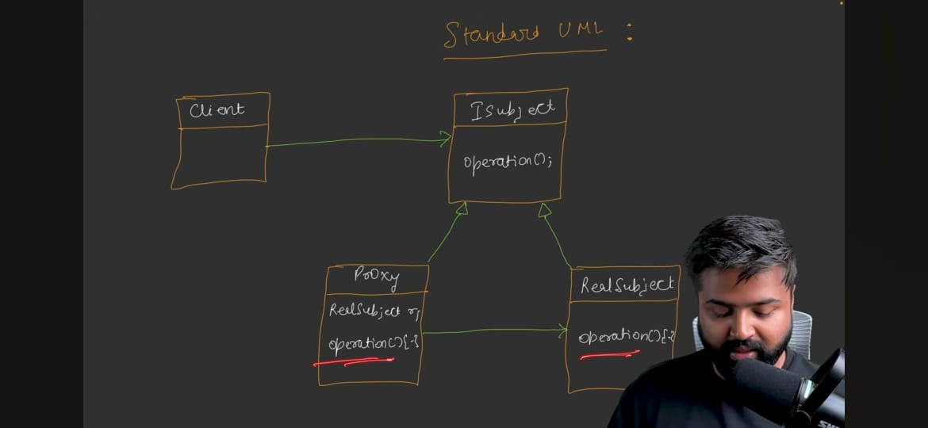
Standard Defination:-
The proxy pattern provides a surrogate or placeholder for another object to control access to it
Use cases:-
- Authentication, premium, login feature
- When there is a service available on the internet

